Iron Triangle
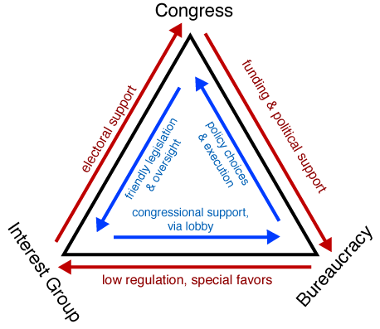
In the United States, bureaucratic power is exercised in the Congress, and particularly in congressional committees
and subcommittees. By aligning itself with selected constituencies, an agency may be able to affect policy
outcomes directly in these committees and subcommittees. This is where an iron triangle
may manifest itself. The picture above displays the concept.

At one corner of the triangle are interest groups (constituencies). These are the powerful interests groups that influence Congressional votes in their favor and can sufficiently influence the re-election of a member of Congress
in return for supporting their programs. At another corner sit members of Congress
who also seek to align themselves with a constituency for political and electoral support. These congressional members support legislation that advances the interest group's agenda. Occupying the third corner of the triangle are bureaucrats, who are often pressured by the same powerful interest groups their agency is designated to regulate. The result is a three-way, stable alliance that is sometimes called a sub government because of its durability, impregnability, and power to determine policy.

Consumers are often left out in the cold by this arrangement. An iron triangle can result in the passing of very
narrow, pork-barrel policies that benefit a small segment of the population. The interests of the agency's constituency (the interest groups) are met, while the needs of consumers (which may be the general public) are passed over. That public administration may result in benefiting a small segment of the public in this way may be viewed as problematic for the popular concept of democracy if the general welfare of all citizens is sacrificed for very specific interests. This is especially so if the legislation passed neglects or reverses the original purpose for which the agency was established. Some maintain that such arrangements are consonant with (and are natural outgrowths of) the democratic process, since they frequently involve a majority block of voters implementing their will through their representatives in
government.

