Make a Book

Bookmaking Process
To make your own book at Bookemon involves the following steps:
1. Choose a template to Create your book.
2. Use our online book builder to design, Edit and Upload media for use in your book.
3. When finished with your design and editing, review your book pages and covers carefully and then proceed to Publish.
4. Further inspect your book pages either online or download the book page and book cover print ready file for detailed review before approving it for publication.

Create a Book
Click the "Create" link in the top navigation bar near the top of the screen and you will be directed to where you can choose various options to begin your book project.
Select one of the three options and click "Create Now" to start:-
Option 1: Start with a blank template
Option 2: Create from documents - support Word, PDF and PowerPoint files
Option 3: Start with a pre-designed template: Click the "Select the template" button next to the template
and product format you have chosen to start.
Entering book information on Product Information Page
Enter the book title, subtitle (optional), author's name,
tags (simple words/phrases to describe your book to make it easier for you and others to find your book at Bookemon), book description, and author's bio.
Book Privacy: Decide how you wish to share your book. Under the Privacy setting, you can make your book available to the Public, Friends Only, or keep it Private (Default) so only you or someone you invited can access your book.

Edit a Book
Editing your book:
To edit your book, click on "Edit" or "Edit Book" command next to the title of your book under My Books of your myHome page or on the right panel of the book profile page when you click on the title of your book. This will direct you to the online book builder to work on your book project.
Within the builder, you can Upload and add photos, clipart, documents into the book and use the book builder miscellaneous functions to design and edit the book the way you want.

Publish a Book
Publish means Print Production Ready Only:
Unlike traditional publishing industry terminology, "Publish" at Bookemon simply means getting your book to be ready for print production.
You will be able to control the privacy of your book in terms of its access and who can purchase it.
During Publish you will be asked to inspect your book for typos, design issues and mistakes you would like to correct before approving it for print production.
We would strongly recommend that you use the "Print Preview" function within the book builder to carefully review your page designs, text content and placements of image/text/photo objects prior to initiating Publish.
Publishing Steps:
1. Book Web Profile - enter relevant book and author info to be displayed on the web profile page of your book.
2. Copyright Information - enter additional legal language, acknowledgement and author information that will be printed on the copyright page of your book.
3. Add page number - in case you didn't add page numbers while editing your book, you can choose to add page numbers during Publish.
4. Set Profit and Privacy - in case you would like to make a profit when others purchase your book, enter the profit amount you like and our system will compute the list price automatically. If you don't want to make a profit, please enter zero into the My Profit entry.
You will also need to set the Privacy for your book in order to control who can access and purchase your book. Please make sure you set it to Private or Friends Only if you do not want the book to be available to the public.
5. Book Files Inspection - this is a critical step for you to carefully inspect the pages and covers of your book to make sure you are completely satisfied with it before you approve it for print production. You also have the option to download your book page and book cover print ready files onto your PC for detailed inspection. Please make sure you take the time and effort to inspect your book!

Make New Edition
Making corrections to your published book:
A book once published cannot be edited. However, you can use the "Make new edition" function to replicate your published book into a new edition. Then, you can freely make corrections, changes or personalize the new edition.
Making hardcover or softcover edition:
You can also use the "Make new edition" function to create a softcover or hardcover version of your published hardcover or softcover book.
That way, you will be able to have both a softcover and a hardcover edition of your book that you can purchase and/or send as gifts. Changing the format of your book:
Depending on the format of your book (not available to all formats), you may be able to create a new edition of your book in a different format. When you use "Make new edition", other format options, if available, will be presented to you for your selection.

Book Builder Functions
Most of the book builder functions are organized under 3 top menu bars:-
1. Page Tools
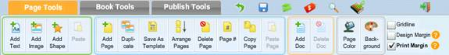
2. Book Tools
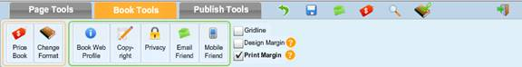
3. Publish Tools
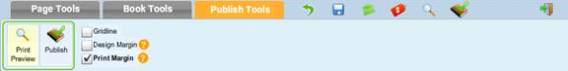
In addition there are miscellaneous short cuts next to the menu sections at the top.

Add a Page
Under Page Tools you will find "Add Page". There are 4 options available:
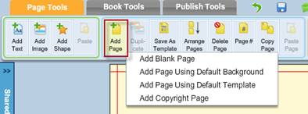
1. Blank Page - A blank page will be inserted after the current page position.
2. Add Page using default background - If you have chosen a specific background (either in color or with an image) and set it as default background, then the new page added will have the same background.
3. Add Page using default template - If you have used the "Save as Template" function to save one of your book page as a page design template, then the new page added will have the same page design as the template.
4. Add Copyright page - If you have somehow deleted the copyright page included in the book initially, you can add it back into your book with this function. The copyright page will be added and placed at Page 2 position.

Add Document
You can add a Word, PDF or PowerPoint file into your book as book pages, "Add Doc" under Page Tools will direct you to the Document section under Media Library to do so.
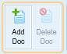

Use a document page as the Front Cover (same process for back cover)
Click Front cover page to make it display on the central stage.
Select the document you've uploaded and click on the green "+" button as shown. You will be presented with various options to add selected or all of the pages in your document into the book.
Unselect all the pages except the page that you want to use as your cover.
Make sure the check box is checked if you want to use selected page as the cover:
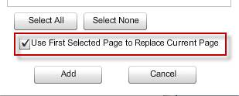

Book Price
You can get an estimate on the cost of your book in bookstore quality print by using the "Price Book" function under Book Tools.
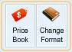

Book Privacy
To change the Privacy of your book, use the "Privacy" function under Book Tools.
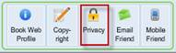

Change Format
In limited situation, we do provide you with the ability to change your book to a different book format (size and color) after it has been created. Please note that this option is not available for all book formats. Use Change Format under Book Tools to see your options:
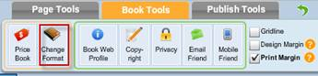

Copyright
"Copyright" under Book Tools is a short cut to edit or add your copyright page.
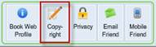

Enter & Edit Text
To enter and/or edit text on page, click on text box where you want to enter/edit text and its Edit Menu bar will be displayed. Click on "Edit" to enter the Text Editor.
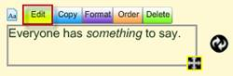If there isn't a textbox placed onto the page already, simply add a Text box by using the "Add Text" function under Page Tools.
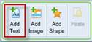

Page background
Accentuate your book page by adding a background color or background image using the "Background" function under Page Tools.
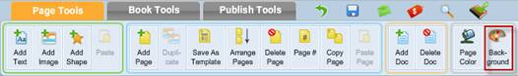

Print Preview
While you are working on your book, it is a good practice to use "Print Preview" located as a short cut on the Top Menu Bar. This will let you view your book pages close to how it will be printed in print production.

Book Media Resource Libraries
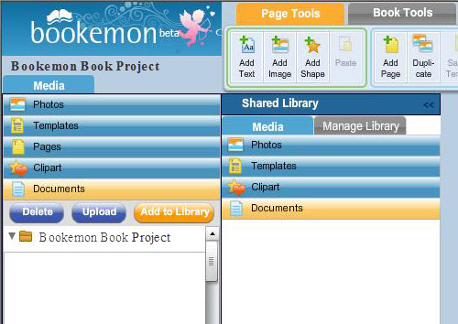
The Media Resource Libraries are designed to give you convenient access to all of the media you have uploaded into your book or media shared by members of your Shared Library. In addition, you have access to Bookemon's free to use, page templates and clipart libraries to help you design your book.

Add Photo
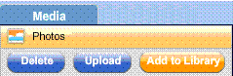
Upload photos into your book: To add photos for use in your book, use the Upload function under the Photos section of the Media Library. You will be able to upload one or more photos in JPG and/or PNG formats into your book.
Add photos to your book pages: Go to the Photos section of the Media library or the Shared Library. Select a photo and use your mouse to Drag N' Drop the photo anywhere on the book page. To place it exactly into an image box already on the page, drag the photo inside the frame of the image box and then drop it in.
Add to Library to Share: You can easily share your photos with members of your Shared Library for use in their book projects. Select the photos you would like to share by marking the checkbox next to the photos and then click on the "Add to Library" button to make it available in the Shared Library.

Add Clipart
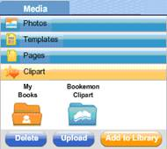
Bookemon Clipart: Bookemon provides you with a free to use library of clipart to help you design your book. You will find a variety of clipart classified under different categories that you can freely use in your book.
Upload clipart into your book: To add clipart for use in your book, use the Upload function under the Clipart section of the Media Library. You will be able to upload one or more clipart in GIF, JPG or PNG formats into your book; your own clipart will be organized under the My Books folder.
Add clipart to your book pages: Go to the Clipart section of the Media library or the Shared Library. Select a photo and use your mouse to Drag N' Drop the photo anywhere on the book page. To place it exactly into an image box already on the page, drag the photo inside the frame of the image box and then drop it in.
Add to Library to Share: You can easily share your clipart with members of your Shared Library for use in their book projects. Select the photos you would like to share by marking the checkbox next to the clipart and then click on the "Add to Library" button to make it available in the Shared Library.

Add Documents
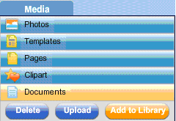
Upload documents into your book: You can use Word, PDF or PowerPoint documents as content in your book. To add documents for use in your book, use the "Upload" function under the Documents section of the Media Library or Shared Library.
Add a document as book pages:
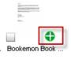
Select a document and click on the + button as shown. You will be presented with various options to add selected or all of the pages in your document into the book. If you are currently viewing the front or back covers of your book, you will be given additional options to replace the current cover design with a page from your document.
Add to Library to Share: You can easily share your document with members of your Shared Library for use in their book projects. Select the document you would like to share by marking the checkbox next to the document and then click on the "Add to Library" button to make it available in the Shared Library.
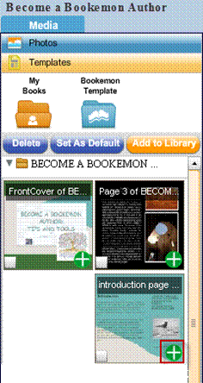

Design with Page Templates
Bookemon Templates: Bookemon provides you with a free to use library of Page Design Templates to help you design your book. You will find a variety of Templates under different categories that you can freely use in your book. Please note: In order to insure proper printing, only page design templates that are compatible in size and orientation will be available in your book. As a result, the number of templates available at the Template section of the Media Library will vary depending on your book format.
Save Template for use in your book:
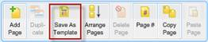
If you have a page design that you would like to use in all of your books, you can use the "Save As Template" function under Page Tools menu in the book builder. Once a page template has been saved, it will be available to you in the Template section of the Media Library under the My Books folder.
Using Page Template in your book:
You have two ways to use the templates in the design of your book.
1. Replacing the current book page with the template: Select the template you like to use, click on the thumbnail of the template and you will be prompted to confirm that you would like to replace the current book page using the template design instead.
2. Adding a new page with the template design: Select the template you like to add into the book, click on the + button as shown and you will be able to add a new page into the book using the template design you have selected.
Select a Template as Default Template: If you intend to use the same page design for your entire book, then the Set as Default function will save you time when you add pages into the book. When you use the Add Page function in the builder, you will be able to use the Add Page Using Default Template option.
Add to Library to Share: You can easily share your template pages with members of your Shared Library for use in their book projects. Select the template you would like to share by marking the checkbox next to the it and then click on the "Add to Library" button to make it available in the Shared Library.

Collection of Book Pages
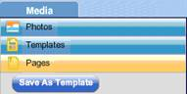
To facilitate re-use of your book pages, we have provided you with a collection of book pages in the Pages section of the Media Library. All of book pages in your books that are compatible in size and orientation with the current book will be available to you. You can use these pages similar to how you would use templates for your book project.

