Name_____________________________________ Period
CELLS TIC TAC TOE – MEDIA INTERACTION
Directions: Fill in the VENN Diagram to compare PLANT CELLS to ANIMAL CELLS. Use the words in the word box.
cell membrane | cell wall | chloroplast | cytoplasm
mitochondria | nucleus | ribosome | vacuole

PLANT CELL |  | ANIMAL CELL
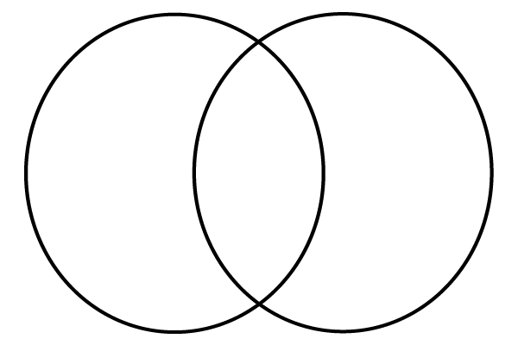

Draw a diagram about photosynthesis in the space below.

What happens in the mitochondrion?

_______________________________________________________________

_______________________________________________________________

_______________________________________________________________

What do the lysosomes do?
_______________________________________________________________

_______________________________________________________________

_______________________________________________________________

In the video, cell parts are compared to a city. Create a list of cell parts used in the video and the part of a city that they were compared to.

Cell Part | City

