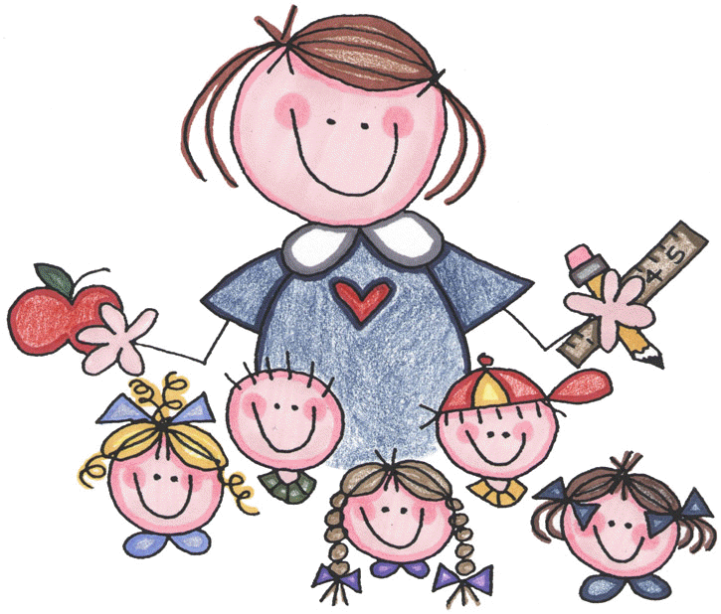
Welcome !
I am really looking forward to getting to know you and your child. It is going to be a great year! Being a kindergarten parent sure can be tough. Here are some helpful tips to help you as you go along . Consider it your little “cheat sheets.”

- Parent Orientation is Sept. 18th at 6:30 PM. Please plan on attending without children. I will be sharing a lot of important information . It should last about 30 minutes. You will also sign up for conferences and meet “Maggie” our class monkey (not real, but the kids think she is)
- Your child may arrive to school beginning at 7:30 AM. The first bell rings at 7:50, and school officially begins at 8:00. If your child arrives late (even 8:01) you must walk your child in to the office and the secretaries will give your child a late pass to enter the classroom.
- If you are bringing your child to school, you may walk in with him/her for the first day. First day pictures are so fun! After the first day, it’s best to allow your child to walk into school without you. I know this is tough, but it makes the transition into the classroom much easier for him/her. Teachers will be in the hallway to help direct your child. I will be there greeting him/her with a big Kindergarten smile of course! If your child rides the bus, it’s best to begin this habit from the start. This will help the bus driver and your child get to know each other right away. It will also help to establish routine from the start.
- The dismissal bell rings at 2:30. If you are picking up your child after school, please park by the lunchroom (way in the back by the playground) and your child will be waiting for you in the lunch room at 2:27 with Mrs. Gaston, a teacher who helps at dismissal. You have to get out of the car and go to the door. You are not allowed to come to the classroom at any time without permission from the office.
- Please be sure your child brings a healthy snack to eat each day (fruit, veggies, crackers and cheese, pretzels, etc.). It’s often hard for children to eat when they first get up, but please try to encourage even a nibble of something small. The morning snack will help to refuel their brains and bellies. Please put snack in the bookbag separate from lunch (same spot each day ). Please be sure to return all forms:
    - Policy Agreement form on top of envelope.
    - From Screening last week if applicable (I left the forms at your table if they are missing):
      - Blue card (1), transportation notice, (indicate a bus buddy if you have one in mind for your child), white questionnaire (from screening), orange parent checklist.
- All forms in the envelope can be taken home to look at. They include
    - The district calendar, district forms, the lunch menu, etc.
- Your child may ride a different bus number home than the one he/she takes to school. I can help you find your child’s bus number on the way home if you aren’t sure. PLEASE BE SURE THAT YOU ALREADY FILLED OUT THE TRANSPORTATION NOTICE AND INCLUDED A BUS BUDDY IF YOU KNOW ONE.
- Changes in transportation need to be in writing. If your child is going home with a friend or a friend is visiting your house, both children need a note. If you forget or plans change during the day, please call the office (995-7250) to report the change. Without a written note or direction from the office, your child will go home his/her usual way.
- ******Lunch details:
  - 11:00-11:25 Lunch with Mrs. Gould’s, Mrs. Feldman’s, and Mrs. Gilchrist’s class in the multipurpose room. Please do not be alarmed…it often takes the kiddos a bit of time to get accustomed to eating their lunch..I will remind them to eat and not just chat .
  - 11:25-11:50 Recess
  - Your child may buy lunch for $2.65 and milk for $.50.
  - Please keep the menu at home handy. This will be the menu for the entire school year. Tomorrow we will be on Wednesday of Week 2. If you are confused as to what week we are on, please refer to the color coded calendar on the right side of the lunch menu . If you misplace the menu, please let me know and I can send home another one. You can also access the menu at http://www.mayfieldschools.org/docs/Mayfield%20Elementary%202013-2014%20Menu.pdf
  - Your child will have his/her fingerprint taken so everything is done electronically when paying. Please add money in your child’s account before he/she buys. Please be sure all money sent in is in an envelope marked with your child’s name and “Food Service.” Checks should be made out to Mayfield Food Service. You may also go to http://www.myschoolaccount.com/Login to add money to your child’s account via the Internet.
- No toys are permitted at school (until show and tell starts on Fridays) .
- For the first few weeks of school, please pin notes to your child, especially changes in transportation. All money (lunch, membership dues, etc.) should be sent in an envelope marked with your child’s name and the purpose.
- Please be sure your child wears a nametag tomorrow and all next week. It should include: child’s name, address, phone number, my name (Palmisano), and how he/she goes home (ex: bus #, walker, car, etc.).
- A folder will go home NIGHTLY. Please be sure to look through the folder, empty the papers, and return the necessary ones. Thank you!!!
- The special schedule is from 12:45-1:30:
  - Monday- Art (need an art shirt - A big (dad’s size) t-shirt that is easy to get over their heads.) Name on it please!
  - Tuesday- Library (Your child must return his/her book to get out a new one). Your child will not be checking out books right away. Books may be returned earlier than library day. We have a crate in our room for them.
  - Wednesday- Art (will rotate each quarter)
  - Thursday- Gym (Please be sure your child wears gym shoes…velcro best if possible). Leave a pair at school if you would like. Please also send in an extra pair of socks to be kept in your child’s bag.
  - Friday-Music
- Your child will need two shirts…one for art and one for orientation. If you haven’t already, please send in an old shirt with your child’s name labeled on the inside of the collar to be used in art class. Your child will also need an everyday shirt that he/she wears to use for a project that we will return in the same condition. Please write the name on the tag or stick a piece of tape on the shirt with his/her name on it. .
- Label everything!! (lunch box, snack containers, bookbag, hats, gloves, mittens, etc.)
- For birthdays, the school allows only non-food items (pencils, erasers, little toys, goodie bags, etc.). Summer birthdays will be celebrated towards the end of the year. Weekend birthdays can be celebrated on Friday or Monday. PLEASE DO NOT SEND INVITATIONS FOR PARTIES TO SCHOOL UNLESS THE ENTIRE CLASS/ALL GIRLS/ALL BOYS ARE INVITED.

- A weekly Friday report will go home for the first few months of school. The letter/report in the envelope explains this further. This is a great chance to go over the info. with your child. Please do NOT get upset if there are “N’s” at the beginning. It is hard work becoming a Kindergartner. We will practice each day with all the fun things we do. THE FIRST REPORT WILL GO HOME NEXT WEEK.
- Email is the best way to contact me:
  - apalmisano@mayfieldschools.org
  - Phone: 440 995-7293
  - Check out our webpage for updates and information. I will send home weekly letters, but I will also post them on this page with reminders, pictures of our class, etc.
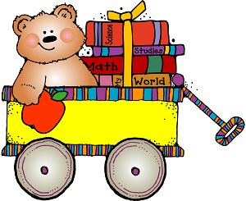
A Kindergarten Parent’s “To Do”
- Send in a shirt for a project we will be making for Parent Orientation labeled with your child’s name on the collar. The shirt will be returned to you unharmed.
- Send in an art shirt to be worn at art class throughout the year. Large T-shirt to be worn over clothing. Be sure your child’s name is on it!
- Please be sure your child has an extra pair of socks to be kept at school and if you desire, a pair of shoes for gym (labeled with his/her name).
- Please fill out all the forms outside of the envelope if you haven’t already.
- Send in a healthy snack with your child in addition to his/her packed lunch (examples: cheese, crackers, granola bars, cut veggies, dried cereal, apples, bananas, etc.). PLEASE NO CHIPS OR COOKIES . Please remember a snack even if they are buying lunch!
- Please make sure your child is in bed by 8:00p.m. or earlier. These are long days and they need a really good night sleep.
- Please send in wrapped a $5.00 birthday present for a gift exchange. Please wrap the present(s) and mark it “Boy” or “Girl.” (Girls buy for a girl; boys buy for a boy) Also include your child’s name so the birthday child can thank them. Send them to school as soon as possible. Please be sure it is a $5.00 gift(s) that a 5/6 year old would enjoy. Game/puzzle/book/toy
- Please remind them how proud you are of their hard work and effort. Trying to do your best work and behave ALL DAY is hard work!!!
- Most importantly, give your child a great big hug! This is a very exciting but NEW time of the year for him/her.

